  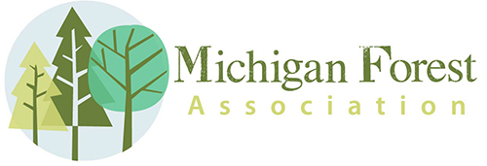

**Newsletter of the Michigan Forest Association**

15851 S US 27 Suite 16 Lansing, MI 48906 - 1987

Phone: 517-816-7879 E-mail: [info@michiganforests.org](mailto:infor@michiganforests.org) Web: [michiganforests.org](http://www.michiganforests.com/)

Volume XXXIV September 2016 Number 03

**Association News**

Deb Huff - Editor

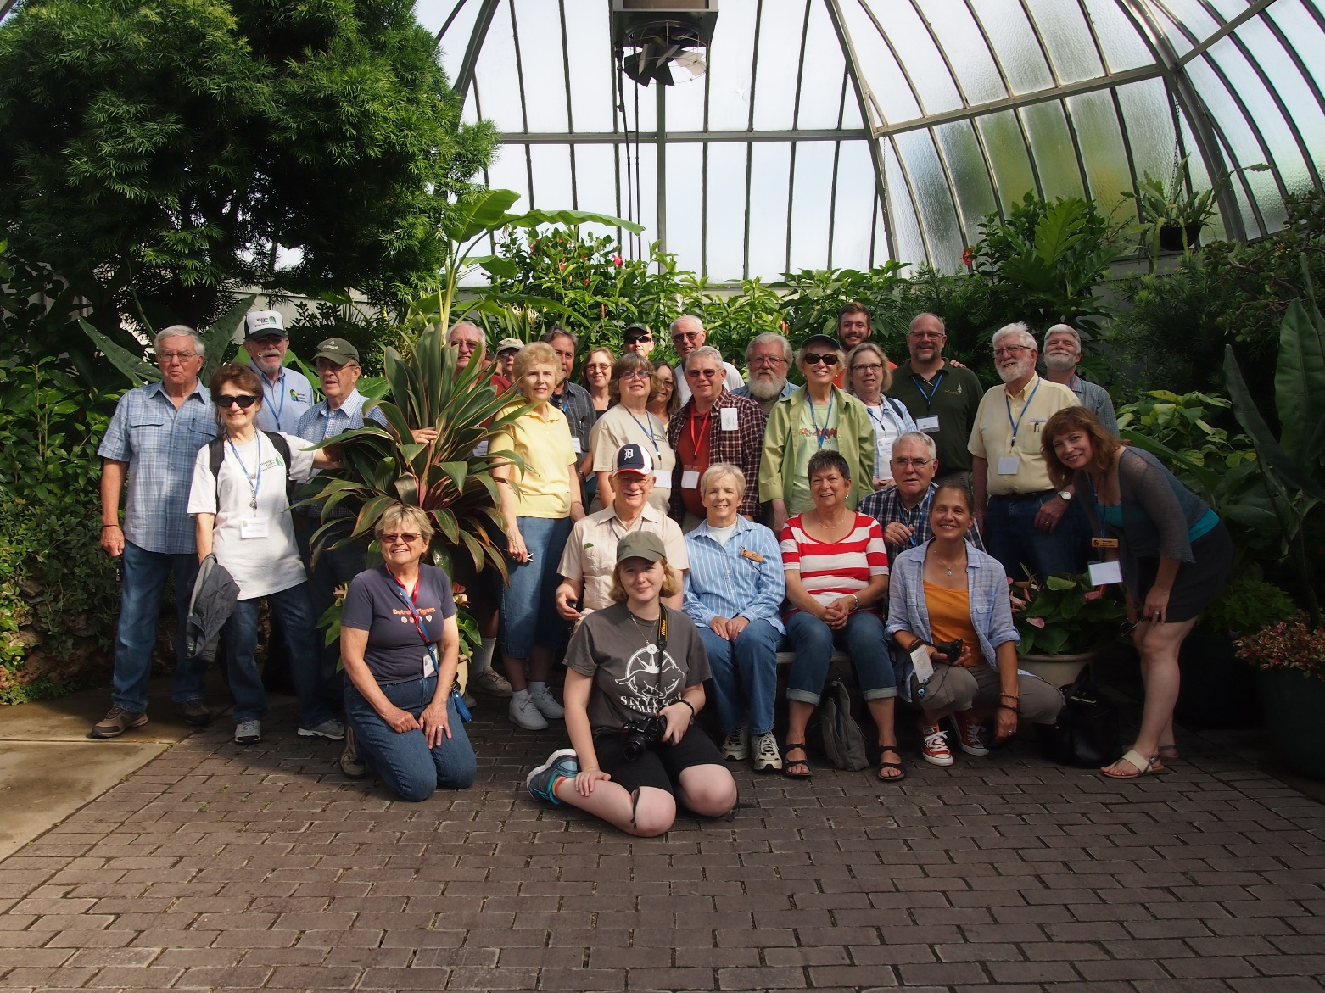

MFA members and guests had a great time visiting urban forestry sites in Detroit and Novi during our annual meeting. Stops included Belle Isle, Hantz Farms and Greening of Detroit planting sites and the Tollgate Farms in Novi.

We saw how forests can be managed well, even in an urban setting like Novi. We heard about the rebirth of green spaces in Detroit, Belle Isle and urban areas. We learned about the importance of forests no matter where you are. It was a rare opportunity to see what is happening in Detroit!

**Coming Events**

Michigan Walnut Council Field Day - Saturday October 08, 2016!

The Michigan Chapter of the Walnut Council is hosting its Annual Fall Field Day for members and those who are interested in attending an informal and educational forest field day. The event is hosted by Des and Marilyn Jones and their families. Refreshments and lunch will be provided - there is no charge for the day's activities which will include: woodlot and plantation tours with discussion by a professional forester; sawmill and edger demonstration with equipment displays; special directional tree felling and tree rope climbing (no spikes) demonstrations!

*Date and Time: Saturday, October 08, 2016 from 9:00 am - 3:00pm*

*Location: 16600 CD Avenue, between 46th and 48th streets, Ross Township, Augusta, MI*

PLEASE RSVP by OCTOBER 02, for planning purposes: contact them via email or phone:

Sharon Jones: skpjones@aol.com

Marilyn Jones: marejones@aol.com

Des Jones: 269-731-5344

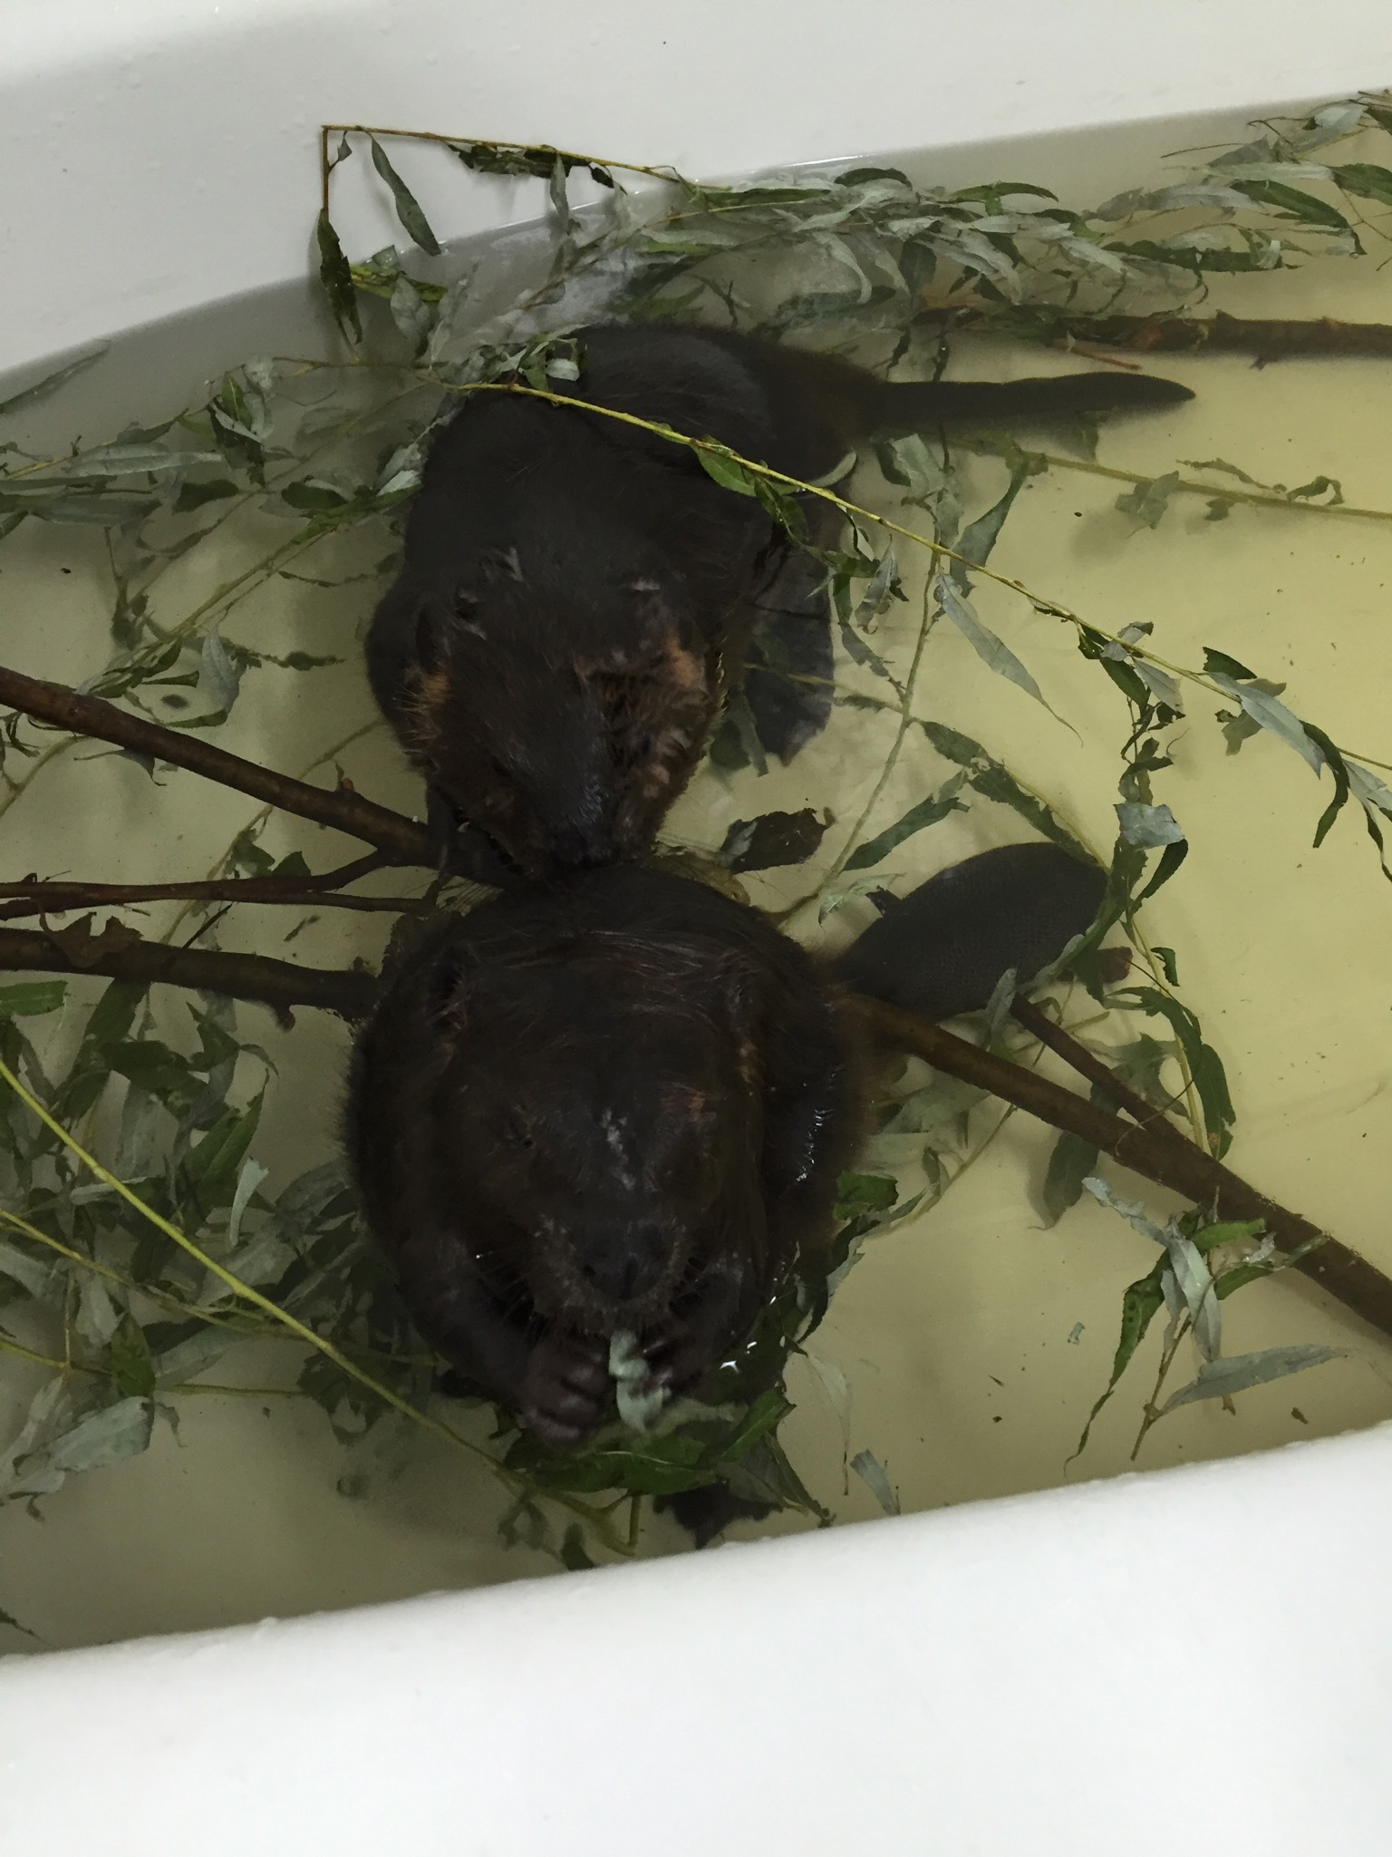

**Can you help these adorable baby beavers???**

WILDSIDE Rehabilitation Center near Eaton Rapids has taken in two baby beavers and they are in need of young aspen tops to feed them! If you can provide material at the road-side, folks from the shelter can pick it up, BUT...residual bar oil from chainsaws is bad for baby beavers. It is okay to fell the tree with a mechanical saw, but it should be bucked with a hand saw. If you can help, please contact the wildlife rehabilitation and education center at 517-663-6153. They are located at 8601 Houston Rd., 3 miles south of the town of Eaton Rapids.

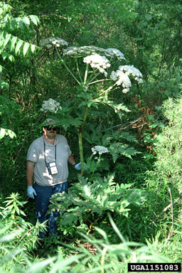

Forest Health

Watch out for Giant Hogweed Plant – it can blind you!

Giant Hogweed is a public health hazard that ranks up there higher than poison ivy, poison oak and poison sumac in respect to its potential to harm humans. The reason for concern is that the sap from this plant can cause a severe skin reaction known as photo-dermatitis or photo-sensitivity. The reaction can happen up to 48 hours after contact. After coming in contact with the sap, the skin blisters when exposed to sunlight. Contact with the eyes can lead to temporary or possibly permanent blindness. The weed can be especially troublesome for children that may find the long stems attractive to play with. If you do come into contact with the plant, and especially the sap, you are advised to wash the affected areas immediately, keep the exposed area out of direct sunlight and seek medical advice. See this video from MSU for more information: <https://vimeo.com/68871229>