  

**Newsletter of the Michigan Forest Association**

**15851 S. Us 27, Suite 16, Lansing, MI 48906**

**Phone 517-816-78779 E-mail** [infor@michiganforests.org](mailto:infor@michiganforests.org) **Web site:** [michiganforests.org](http://www.michiganforests.com/)

Volume XXXV May, 2016 Number 02

**Association News**

**Debra Huff, guest editor**

**NEW OFFICE!** 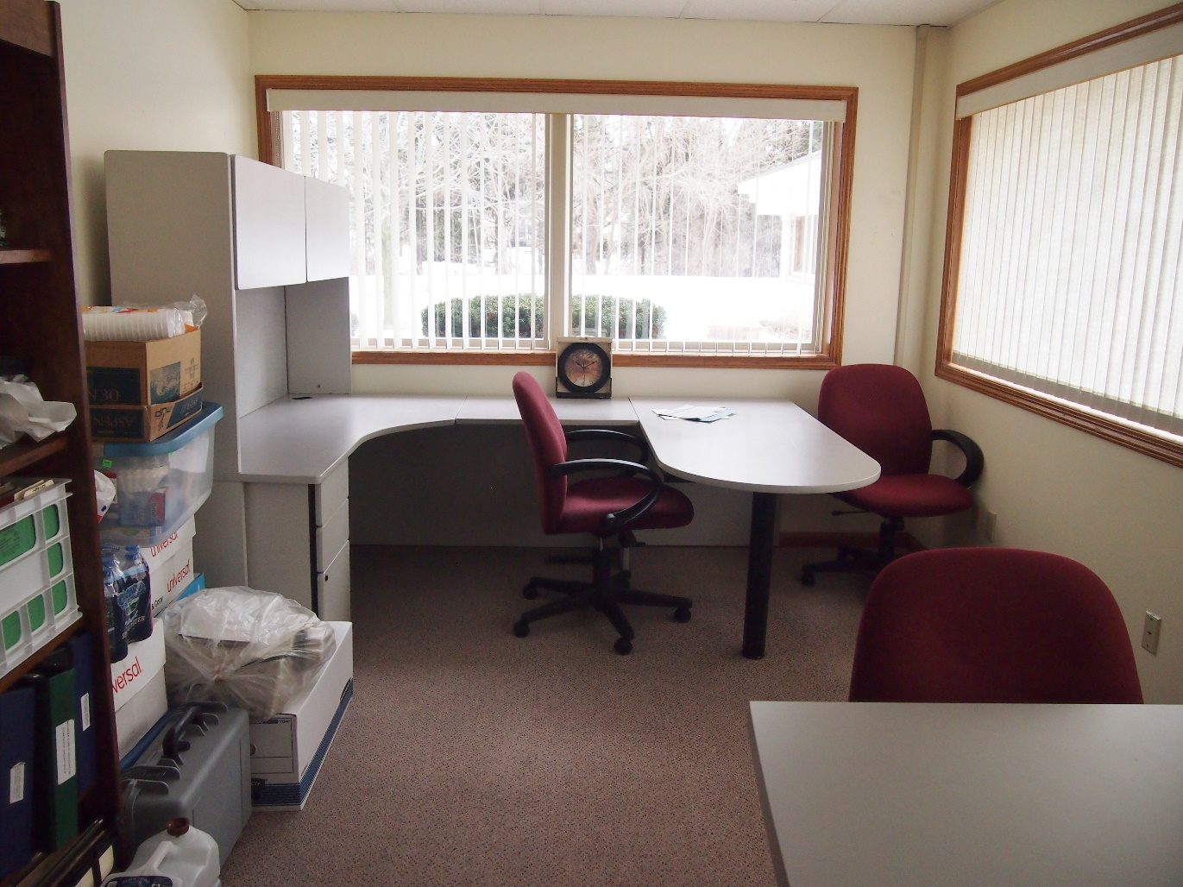

MFA has moved to Lansing! Our new address is:

**Michigan Forest Association**

**15851 S. US 27 Suite 16**

**Lansing, MI 48906**

**517-816-7879**

**Michiganforests.org**

Your contacts will be Debra Huff and Lisa Parker at the new address. Members are all welcome to stop by anytime, just call first to be sure one of us is around to open up the office. If we aren’t there, press 1 to leave a message! I will try to be in the office on Tuesday mornings from 10- 1pm. Deb [debra.huff@michiganforests.org](mailto:debra.huff@michiganforests.org)

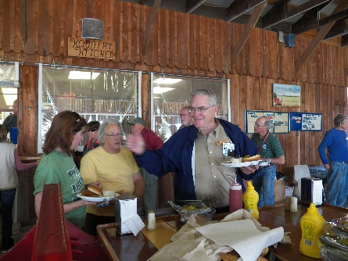**Coming Events**

**MFA annual meeting**

A rare opportunity to see how forests are making a comeback in urban areas! Foresters, landowners, citizens will all learn something about a way we are finding a renaissance of forests in the Detroit area!

**MFA Annual Meeting 2016 Schedule** (Subject to minor adjustments)

**Thursday August 18, 2016**

1:00pm – 5:00pm MFA Board of Directors Meeting

BBQ dinner at Lakeshore Park in Novi

**Friday August 19, 2016**

9:00am – 10:30am MFA Business Meeting

**The Renaissance of Forests in the Detroit area – Urban Forests Emerge!**

Citizen Foresters working together with professional foresters to bring the forests back to the city Greening of Detroit – Jack Kyle, Environmental Education Director

Insights into Community Forestry Davey Tree Services & Consulting foresters – Lee Mueller

Managing Forty acres of forest in a suburban metropolis Tour Tollgate Farms in Novi, MI*.*

**Evening Festivities**: Banquet, Awards, Auction & Raffle

**Saturday August 20, 2016 Load buses at 8:30 am**

Bus Tour of the Renaissance of Forests in the Detroit area!

**Belle Isle State Park** – **A natural resource jewel for forests, wildlife and people.**

**Greening of Detroit**: Jac Kyle, **Citizen Foresters in action at Rouge Park.** Creating new forests and engaging local residents!

**Hantz Farms**: **Private enterprise endeavors to change urban blight to healthy woodlands**. Oaks, maples, and other high value trees planted in straight, evenly spaced rows. Grass between rows of trees will be mowed regularly, and flowering trees will be planted between streets and sidewalks to create a breathtaking place of beauty each spring and fall season. They are trying to build a new, green economy in Detroit, and lead the world by example. Join us in viewing this innovative endeavor.

**Optional evening activities: Tigers Baseball game with MFA! Detroit Tigers VS. Boston Red Sox!**

**Woodward Avenue Dream Cruise! Many other choices.**

**MFA Teacher Workshop at R.A.MacMullan Conference Center, Roscommon**

June 20 – 24, 2016

A registration form is attached at the end of this newsletter!

**Our apologies**

Dues: Yes, you will be receiving a dues notice, and you are a welcome member! We apologize for the delay, but there are always growing pains when one leadership transitions to another. Please bear with Lisa and I as we are doing our best to match what Bill and Alice did for us!

Please also pardon the lateness of the Forest Leaves Newsletter. We promise to do a better job as we get ourselves organized and moving into the future. We do have a lot of exciting things happening and can’t wait to tell you all about it!

**Wildlife News**

**Chronic Wasting Disease – Mandatory deer checks in 5 counties**

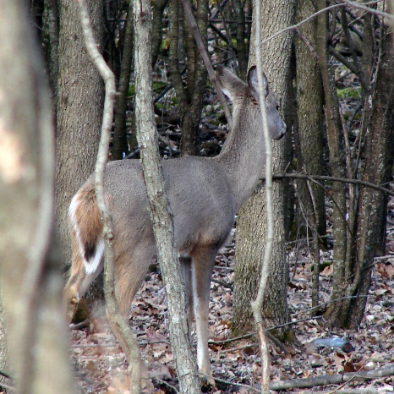

May 2016 - The Michigan Natural Resources Commission has approved a Department of Natural Resources plan to expand the Core CWD Area from nine townships in three counties to 17 townships in four counties. A broader CWD Management Zone, which includes fewer restrictions than the core area, now includes Eaton and Ionia counties, along with Clinton, Ingham and Shiawassee counties.

Successful hunters in the eight new townships will be required to take their deer to a DNR check station to be tested for the fatal neurological disease. And baiting likely will be outlawed in all five counties.

DNR officials have scheduled two new town hall meetings to discuss the management changes and the DNR's response to the outbreak. The meetings will be June 1 at the Foster Community Center in Lansing and June 7 at the Armory Community Center in Ionia. Both sessions will run from 6 p.m. to 8 p.m.

More information can be found on the Michigan DNR website.

**Forest Health**

**Spruce Budworm numbers are increasing in the Upper Peninsula**

**~** From 2015 Forest Health Highlights, published by the Michigan DNR 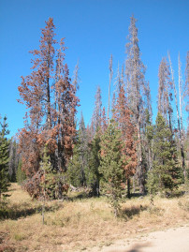

It appears that Michigan has entered the beginning years of the next regional spruce budworm (SBW; Choristoneura fumiferana) outbreak. The entire western Upper Peninsula, areas in the eastern Upper Peninsula and areas in the northeastern Lower Peninsula were defoliated by SBW for the second consecutive year. Epidemics of spruce budworm periodically cause extensive defoliation and tree mortality in spruce and fir forestsLarge scale SBW outbreaks cause widespread top kill and tree mortality. Mature and over-mature balsam fir dominated stands are most severely damaged. Susceptible stands often lose 60 to 80 percent of the fir and 20 to 40 percent of the spruce. Mature fir stands may be entirely lost. The last outbreak in Michigan started in the Upper Peninsula in the late 1960s and ended in the early 1980s. Over 519,000 acres of spruce and fir trees died in Michigan as a result.

Photo from WA DNR

**Forest Products**

**Tall Wood Buildings.** A new bill from Congress would establish performance driven research for advancing tall wood building construction in the U.S.

The “Timber Innovation Act” would:

·        Authorize the Tall Wood Building Prize Competition through the U.S. Department of Agriculture (USDA) annually for the next five years

·        Create federal grants to support state, local, university and private sector education, outreach, research and development, including education and assistance for architects and builders, that will accelerate the use of wood in tall buildings

·        Authorize technical assistance for USDA, in cooperation with state foresters and state extension directors (or equivalent state officials), to implement a program of education and technical assistance for mass timber applications

The Woodworking Network

**Miscellaneous**

**Carbon Markets**

**USDA Secretary Vilsack commits to investment in forest carbon sequestration**

During a speech on climate at the Center for American Progress in Washington, Agriculture Secretary Tom Vilsack announced a new $72.3 million investment to boost carbon storage in healthy soils as part of the USDA’s Building Blocks for Climate Smart Agriculture and Forestry, one year after he unveiled the plan at Michigan State University.

**Fires**

**Burned Forests of Fort McMurray, are providing habitat to ash loving insects!**

**From** By Wallis Snowdon, [CBC News](http://www.cbc.ca/news/cbc-news-online-news-staff-list-1.1294364) Posted: May 10, 2016 1:42 PM MT

The fires surrounding Fort McMurray have attracted beetles that are part of the fire-dependent ecosystem**.** This Alberta wildfire has torched over 566,000 acres of boreal forest and continues to threaten neighbors in Saskatchewan. However, nature’s recyclers have moved in to prepare for the next forest. These beetles are attracted to the burned areas and thrive in burned landscapes. Peter Heule, an insect expert with Edmonton's Royal Alberta Museum,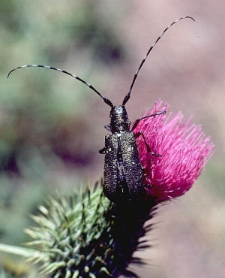 said these pyrophilus creatures are critical to rejuvenating the boreal forest. The most famous of these fire-loving insects is the white-spotted long-horn beetle. The pitch-black, long-antennaed critters feed on conifers such as spruce, pine and fir trees in forests across North America.

Better known as the tar-sand beetle, they are a common sight in Fort McMurray and are much maligned for their tendency to crawl into the warmth of mine-workers pant legs, and latch on.

There's a reason there are so many in the region. Smells of oilsands attract these beetles, and they look for charred wood on which to lay eggs. These insects help turn deadwood back into soil, allowing seedlings to return to the landscape in a matter of months. Research shows that if the insects aren't there to chew their way through the blackened logs, the burned landscape remains stagnant for much longer.

**MICHIGAN FOREST ASSOCIATION**

**15851 S. US 27,** Suite 16, Lansing, MI 48906-1987

**Phone 517-816-7879**

[**michiganforests.org**](http://www.michiganforests.org)

**Email info@michiganforests.org**

**44th ANNUAL MEETING – Woodlands in My Back Yard**

**Headquarters – Monaghan Knights of Columbus Hall**

19801 Farmington Rd, Livonia, MI 48152

**FRIDAY AND SATURDAY, AUGUST 19 AND 20, 2016**

**(Early bird $20 discount until August 1, 2016, Tigers baseball tickets reservations no later than July 13, 2016)**

**REGISTRATION FORM**

|  |  |  |  |
| --- | --- | --- | --- |
| **FULL NAME(S)** | **ADULT** | **CHILD**  **(AGE)** | **ANY DIETARY RESTRICTIONS?**  **PLEASE SPECIFY** |
|  |  |  |  |
|  |  |  |  |
|  |  |  |  |
|  |  |  |  |
|  |  |  |  |
|  |  |  |  |

(Use the back of the form, if necessary, for additional registrants.)

Address (head of party): _____________________________________________

City: __________________ State: _____________ Zip: ______________ Phone: (_____)_______________

Alternate phone: (_____)_____________________________ E-mail: ____________________________________

A list of local motels and campgrounds appears in *Leaves* and on the MFA web site, and will be sent when you register.

Full meeting registration includes all costs except lodging, (including: Friday lunch & Banquet, Saturday bus tour & lunch). The registration fee (but not lodging) for two individuals is included in Oak and White Pine memberships -- **but please register**.

|  |  |  |  |  |  |
| --- | --- | --- | --- | --- | --- |
| **Type of Registration** | **Cost each**  **(pre Aug. 1)** | | **Cost each (after Aug 1)** | **No. of People** | **Amount due** |
| Adult full registration (MFA members & spouses) | | $95 | $115 |  |  |
| Adult full registration (non-members) | | $110 | $130 |  |  |
| Child (ages 5-12) -age 4 and under are free | | $50 | $50 |  |  |
| Friday program with lunch | | $25 | $30 |  |  |
| Friday program with Banquet only | | $35 | $40 |  |  |
| Friday program with lunch and Banquet | | $60 | $70 |  |  |
| Saturday program with lunch and bus tour | | $40 | $50 |  |  |
| Tigers tickets – **by July 13** – 70 available - tickets available with and without bus transportation | | $40 – with bus | $35 – without bus |  |  |
| Raffle tickets - $5 each – Chain saw, Maple table | |  |  |  |  |
| **Total enclosed** | |  |  |  |  |

Please make checks payable to **Michigan Forest Association** and mail to MFA at the above address. Confirmation, maps, and final program will be sent to registrants. **Please register as soon as possible.**

For late registration (after **August 1**), please phone to check space availability.

# Recommended Hotels in Livonia

# Fairfield Inn & Suites

17350 Fox Drive

Livonia, MI 48152

1-734-953-8888

Rates and Reservations CUTOFF DATE July 28, 2016

* Call hotel directly for reservations – tell them you are with the Michigan Forest Association.

Cutoff date: July 28, 2016

* OR go to the website at [www.fairfieldinnlivonia.com](http://www.fairfieldinnlivonia.com/) and enter one of the following codes into the group code box which they will find under "Special rates":

Queen/Queen rooms:   MFAMFAQ

King rooms:    MFAMFAK

King Sofa rooms:      MFAMFAS

King Studio:  MFAMFAE

* OR utilize the link below, which will take them directly to our website with the ability to book a room under your room block. [**Book your group rate for Michigan Forest Association**](http://www.marriott.com/meeting-event-hotels/group-corporate-travel/groupCorp.mi?resLinkData=Michigan%20Forest%20Association%5EDTWFL%60MFAMFAE%7CMFAMFAS%7CMFAMFAQ%7CMFAMFAK%60102-112%60USD%60false%604%608/18/16%608/21/16%607/28/16&app=resvlink&stop_mobi=yes)
* Our special rates at the Fairfield Inn are:

| ROOM TYPE | RATE |
| --- | --- |
| King | $102.00 |
| Queen/Queen | $102.00 |
| King Sofa | $112.00 |
| King Studio | $112.00 |

Please note all rooms are non-smoking. A $250 fee per room will be assessed if there is smoking in any guest rooms. Please note these room rates are per room, per night, and are subject to 10.5% applicable taxes. This contract, which when signed and returned will confirm the above arrangements on a definite basis.

\****Breakfast is included in this rate***.

**Courtyard Detroit Livonia**

17200 N Laurel Park Drive

Livonia, MI 48152-3915

(734) 462-2000

Rates and Reservations CUTOFF DATE July 28, 2016

* Please have the guests in your group directly call Marriott Reservations at 1 (800) 321-2211 or (734) 462-2000 on or before **Thursday, July 28, 2016**, (**the “Cutoff Date”**) to make their sleeping room reservations. Please advise guests to identify themselves as part of the Michigan Forest Association (MFA) group staying at the Courtyard Detroit Livonia, located at 17200 N Laurel Park Drive, Livonia, MI 48152-3915.
* Here is the reservation link your guests can use to make online reservations: [**Book your group rate for Michigan Forest Association**](http://www.marriott.com/meeting-event-hotels/group-corporate-travel/groupCorp.mi?resLinkData=Michigan%20Forest%20Association%5EDETLV%60MFAMFAA%7CMFAMFAB%6099-109%60USD%60false%604%608/18/16%608/21/16%6007/28/2016&app=resvlink&stop_mobi=yes)
* All reservations must be guaranteed with a major credit card. The hotel will not hold any reservations unless secured by credit card. Our special rates at the Courtyard by Marriott are:

|  |  |  |  |
| --- | --- | --- | --- |
| **Start Date** | **End Date** | **Room Type** | **Rate** |
| 08/18/2016 | 08/20/2016 | King | $109.00 |
| 08/18/2016 | 08/20/2016 | Queen/Queen | $99.00 |

* The Hotel’s room rates are subject to applicable state and local taxes (currently **10.50%**) in effect at the time of check out.

***\*Breakfast not included in room rate***